select

month(DATE0),

sum(sls."/BIC/BSSLS000") as Sale_Sum,

sum(sls."/BIC/BSEXC000") as Margin_Sum,

sum("/BIC/BSDIS000") as Discount_Sum,

sum("/BIC/BSPVD000") as Supplier_Sum,

sum(sls."/BIC/BSEXC000") - sum("/BIC/BSDIS000") as Revenue,

t_cgi.txtlg

from "/BIC/ABDSLS0002" as sls

left outer join "/BIC/ABDNOM0002" as nom

on nom."/BIC/BNOM0000" = sls."/BIC/BNOM0000"

left outer join "/BIC/TBCGI0000" as t_cgi

on t_cgi."/BIC/BCGI0000" = nom."/BIC/BCGI0000"

where

year(sls.date0) = 2020 and

month(sls.date0) = 5 and

"/BIC/BEMIT000" = 530 and

t_cgi."/BIC/BCGI0000" in (23, 116, 168, 216, 454, 562, 563, 861, 865, 884, 592, 593, 594, 613, 654, 655, 656, 863, 865, 864, 886, 867, 868, 869, 870)

group by rollup(month(DATE0), t_cgi.txtlg)

order by month(sls.date0) desc

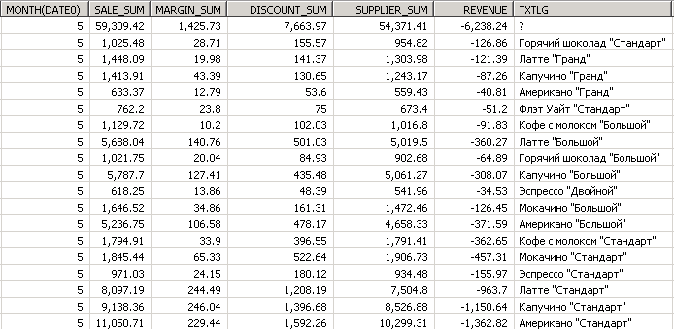

select

distinct

concat(substr(sls."/BIC/BCOM0000", 10, 6), ', ')

from "/BIC/ABDSLS0002" as sls

left outer join "/BIC/ABDNOM0002" as nom

on nom."/BIC/BNOM0000" = sls."/BIC/BNOM0000"

left outer join "/BIC/TBCGI0000" as t_cgi

on t_cgi."/BIC/BCGI0000" = nom."/BIC/BCGI0000"

where

year(sls.date0) = 2020 and

month(sls.date0) = 5 and

"/BIC/BEMIT000" = 530 and

t_cgi."/BIC/BCGI0000" in (23, 116, 168, 216, 454, 562, 563, 861, 865, 884, 592, 593, 594, 613, 654, 655, 656, 863, 865, 864, 886, 867, 868, 869, 870)

select

month(DATE0),

sum(sls."/BIC/BSSLS000") as Sale_Sum,

sum(sls."/BIC/BSEXC000") as Margin_Sum,

sum("/BIC/BSDIS000") as Discount_Sum,

sum("/BIC/BSPVD000") as Supplier_Sum,

sum(sls."/BIC/BSEXC000") - sum("/BIC/BSDIS000") as Revenue,

t_cgi.txtlg,

concat(substr(sls."/BIC/BCOM0000", 10, 6), ','),

t_gds.txtlg

from "/BIC/ABDSLS0002" as sls

left outer join "/BIC/ABDNOM0002" as nom

on nom."/BIC/BNOM0000" = sls."/BIC/BNOM0000"

left outer join "/BIC/TBCGI0000" as t_cgi

on t_cgi."/BIC/BCGI0000" = nom."/BIC/BCGI0000"

left outer join "/BIC/TBCOM0000" as t_gds

on t_gds."/BIC/BCOM0000" = sls."/BIC/BCOM0000"

where

year(sls.date0) = 2020 and

month(sls.date0) = 5 and

"/BIC/BEMIT000" = 530 and

sls."/BIC/BCOM0000" in

(select "/BIC/BCOM0000" from "/BIC/ABDGDS0002" as gds_

left outer join "/BIC/ABDNOM0002" as nom_

on nom_."/BIC/BNOM0000" = gds_."/BIC/BNOM0000"

where nom_."/BIC/BCGI0000" in (23, 116, 168, 216, 454, 562, 563, 861, 865, 884, 592, 593, 594, 613, 654, 655, 656, 863, 865, 864, 886, 867, 868, 869, 870)

) and

t_cgi."/BIC/BCGI0000" in (23, 116, 168, 216, 454, 562, 563, 861, 865, 884, 592, 593, 594, 613, 654, 655, 656, 863, 865, 864, 886, 867, 868, 869, 870)

group by month(DATE0), t_cgi.txtlg, sls."/BIC/BCOM0000", t_gds.txtlg

--group by rollup(month(DATE0), t_cgi.txtlg, sls."/BIC/BCOM0000", t_gds.txtlg)

--having sum(sls."/BIC/BSEXC000") - sum("/BIC/BSDIS000") < 1

order by sls."/BIC/BCOM0000"

SELECT TOP 1000

gds.OrganizationCodeEmitent,

gds.Code,

gds.Description,

gds.Price,

gds.SumIncrease,

gds.SumIncreaseTotal,

gds.DeletionMark

FROM dwbeloil.dbo.Goods_new_3 as gds

where

gds.OrganizationCodeEmitent in (530) and

gds.Code in (

405446,

405448,

405449,

405450,

405458,

405455,

405457,

405447,

405445,

405459,

405451,

405463,

405462,

405456,

405460,

358391,

405464,

405454,

369948,

369949,

369955,

369954,

405692

)

order by gds.Description